Meeting Name: | ASSE Three Rivers Board Meeting Minutes
Date & Time: | 4/13 1:21 PM – 1:49PM | Meeting Location: | Sheraton Lisle
Prepared By: | Anita Worden

1. Attendees
Executive Board |  |  |  | Chairpersons
 | Jeff Winter | X | Brenda Allard |  | Dawn D’Ostilio
X | Pat Genovese |  | Greg Meyer | X | Mery Sennett
X | Anita Worden |  |  |  | Joe Lasky
X | Carol Frye |  |  |  | Angela Aparicio
 | Dawn D’Ostilio |  |  | X | Diane Rigsbee
 | Robert Zima |  |  |  | Stuart Feinberg
X for Attended Jamie Dunn, NEIL attended today’s meeting and board meeting

2. Meeting Agenda
- March Meeting Minutes were approved and seconded. | 1:21 pm
- Presidents Report (Pat)  - PDC in San Antonio June 3rd-6th – Mery is Attending.  - Reminders for next meeting:  - Carol offered for May to provide the personal statement at the beginning of the meeting. | 1:22 pm
- Membership Report (Robert)  - Current Count: 354  - New Members: 2  - Student recruitment: No news | 1:23 pm
- Treasurey Report (Carol)  - May 31st Financial Report Reminder  - Current Funds: $28,662.87  - Budget Update: None | 1:27 pm
- Program Chair Update (Diane)  - OSHA Update Reschedule is set for May 11th  - May 17th – Social Event: Need to speak with Scot Salzman for details.  - Need to set up event to get head count & Secure location (Scot?) | 1:30 pm
- Honors & Awards (Mery)  - The SPY award was presented to Brenda Allard at the meeting.  - 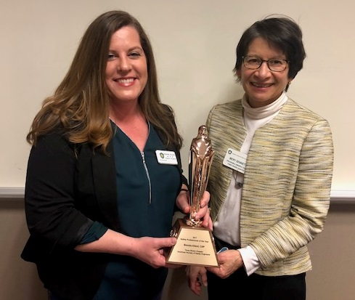 | 1:32 pm
- Website/LinkedIn (OPEN)  - Rob said “Anna” could help out, however, she stated she just changed jobs, This is pending.  - Jamie Dunn, NEILL, is interesting in helping with the website and will also join TRC.  - Updating officers  - Updating P“About”  - Loading pictures & presentations  - Loading news articles and worthy events – | 1:35 pm
- Golf Outing (Joe) (not discussed) | 1:35 pm
- Chicagoland Safety Conference (Anita) – Newsletter blast. Send Brenda the deadline. | 1:40 pm
- New Business  - Elections Committee (Joe offered to be Assistant Treasurer but cannot attend meetings) Brenda will be President, Rob Zima is nominated for 1st VP and still maintain Membership Chair. Pat Genovese will take on Assistant Treasurer. Anita will stay on for Secretary.  - John Rickert spoke with Mery and may be interested in working with the chapter.  - Event Task Sheets – Review Greg’s for Golf Outing – Need to assign another event for this.  - Positions & Time Commitments – Please complete and send in to Jeff Winter.  - Mery announced she is Assistant Administrator for SPALW (Safety Professionals and the Latino Workforce) which is a common interest group of the American Society of Safety Engineers.  - Survey Questions for next meeting – none were identified. | 1:41 pm
- Adjourn | 1:49 pm

